EPCP

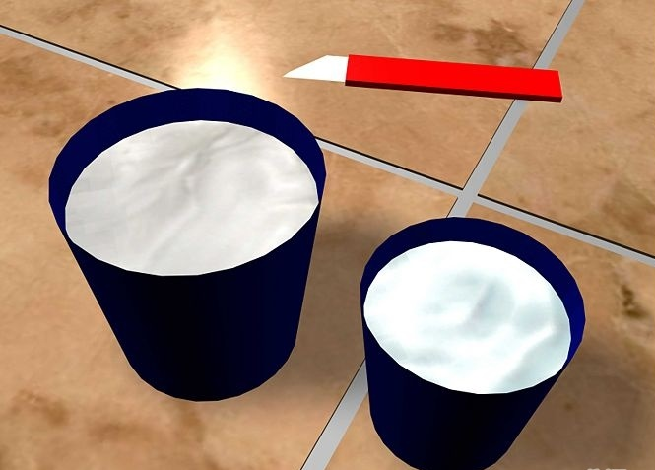

When Quality is your goal..
www.epco-eg.com
T: +20-2-22618433/ +20-2-22638384 F: +20-2-22618433
249 Ramses Ext. 2, Nasr City, Cairo, Egypt.

